**Lab Mid**



**Submitted to:** Yasmeen Jana

**Submitted by:** Mehak Kausar

**Registration No:** SP22-BSE-044

**Course title:**  Advanced Web Technologies

**Department of Computer Science**

**COMSATS UNIVERSITY ISLAMABAD,**

**VEHARI CAMPUS**

**Book-App**

**File Structure:**

book-app/

│

├── backend/

│ ├── models/

│ │ └── Book.js

│ ├── routes/

│ │ └── books.js

│ ├── .env

│ ├── server.js

│ └── package.json

│

└── frontend/

├── index.html

├── add-book.html

├── css/

│ └── styles.css

└── js/

└── main.js

**.env file:**

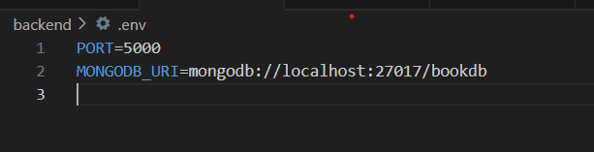

**Backend:**

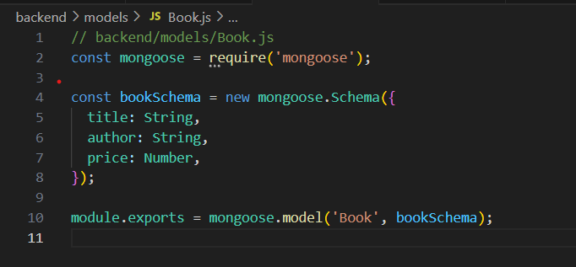

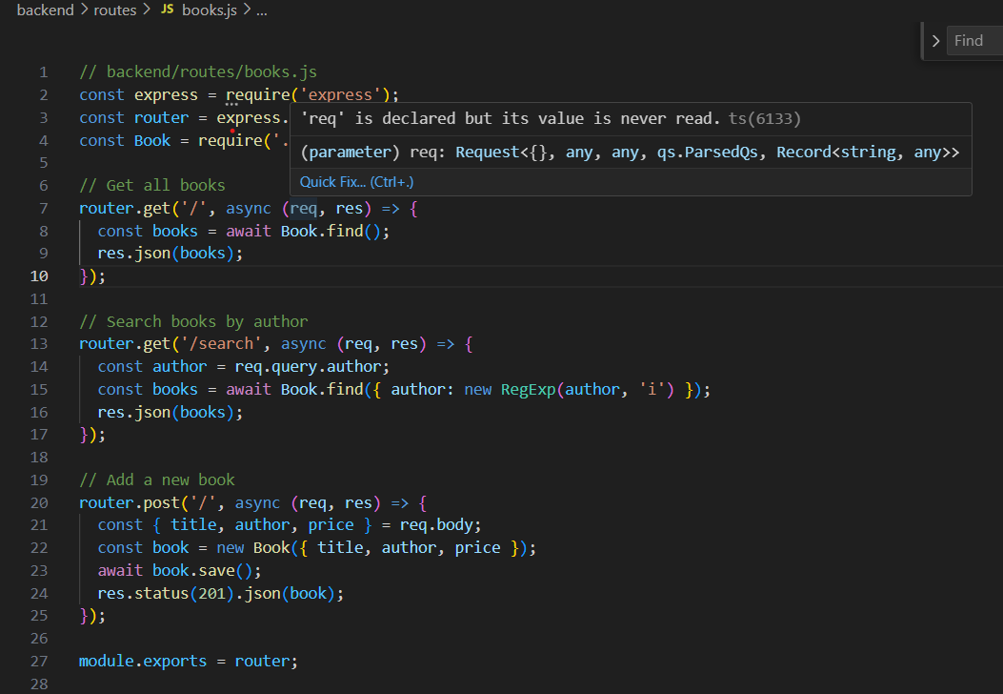

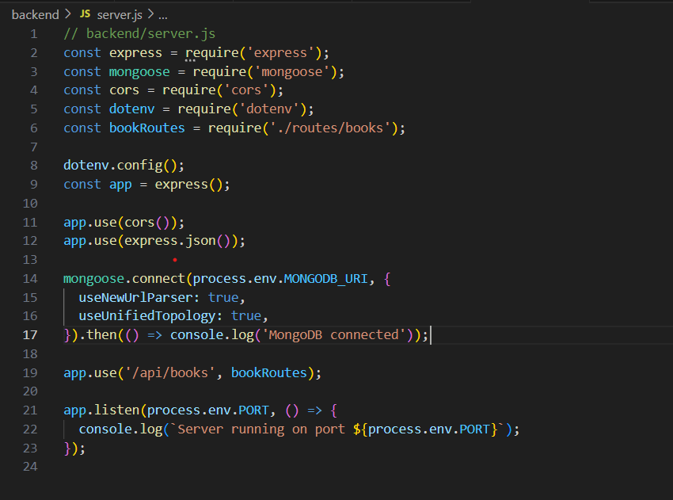

**Frontend:**

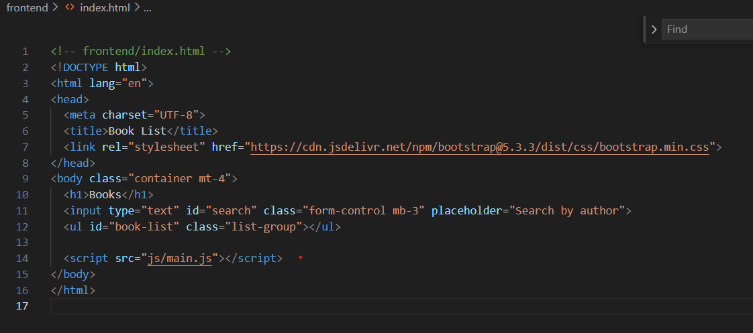

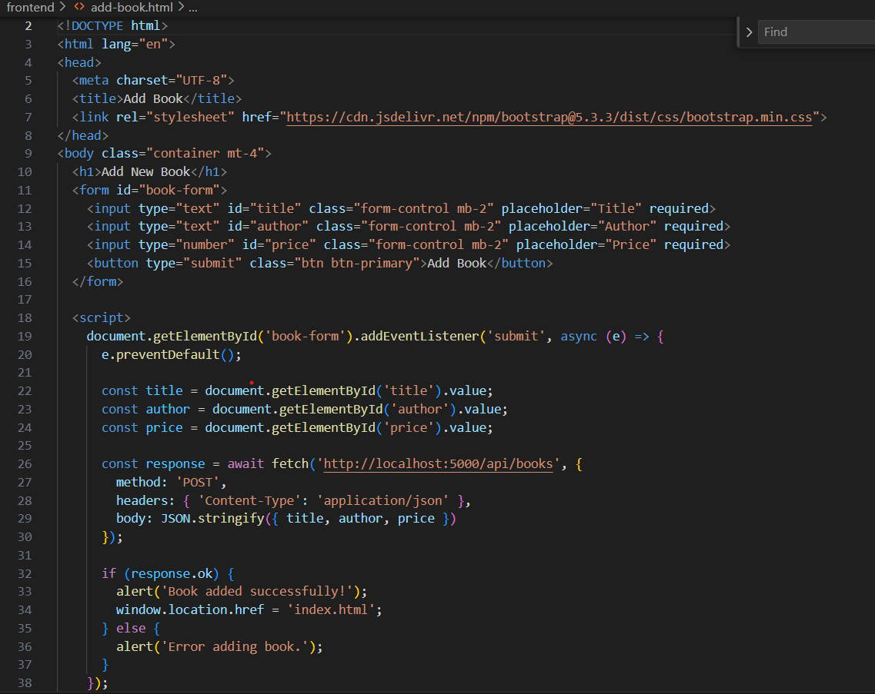

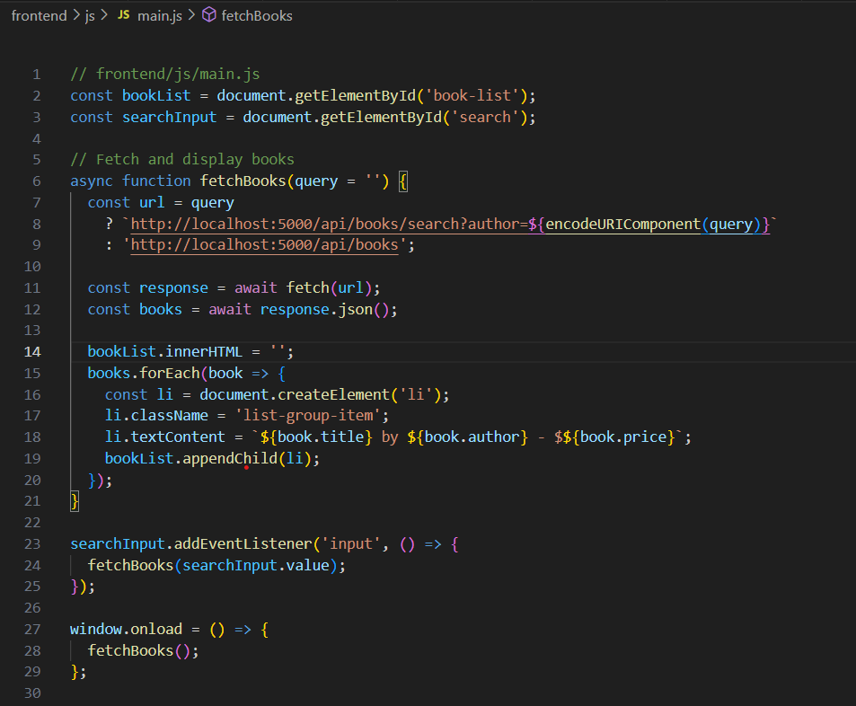

**Run Terminal:**

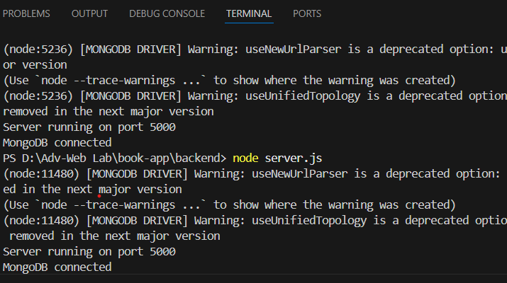

**Output:**

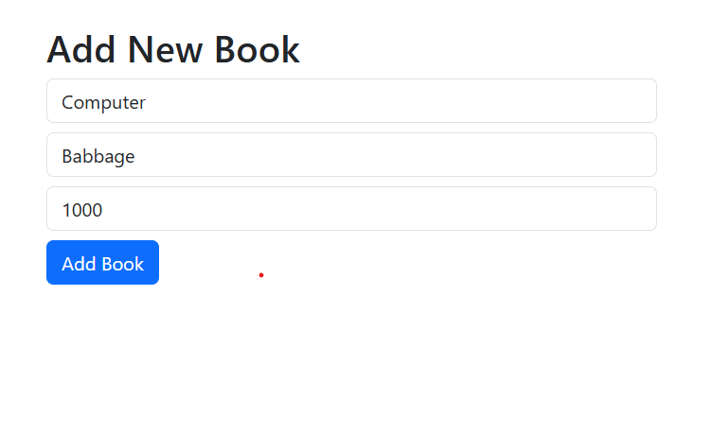

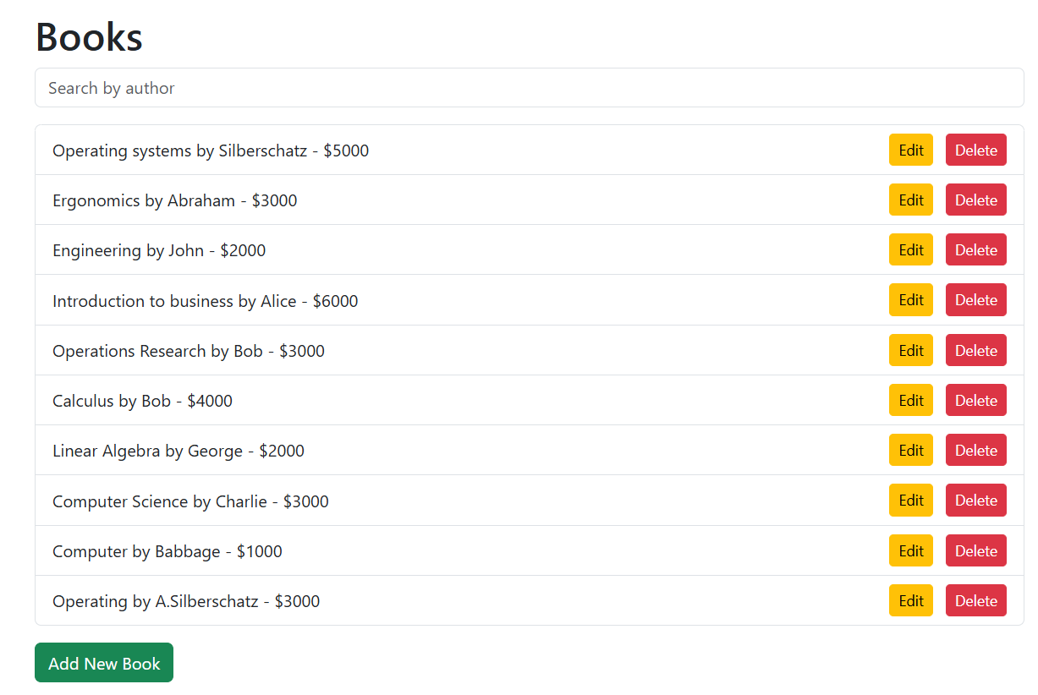

**Postman:**

